
LEEDS POTTERY

Brothers’ John and Joshua Green in partnership founded LEEDS POTTERY in Leeds in 1770 with Richard Humble. Success soon came with the production of household goods in a variety of ceramic bodies, the most popular being CREAMWARE, a type of earthenware made by several companies from white Cornish Clay with a translucent glaze, producing the pale cream colour from which it took its name. In an age when the rediscovery of Rome's classic past brought a new elegance to design and ornament, pottery from Leeds with its fine embossing and intricately pierced open-work decoration reached a peak of perfection.
Creamware
For the 18th century Leeds potters creating this range of ware the clarity and simplicity of cream colouring meant that its appeal would rest on elegant shapes. Classical proportions and flawless craftsmanship coupled with moulding and openwork decoration, which was imaginative yet restrained. The same qualities are evident today in ware unchanged from the original designs and which still involves painstaking work to cast, jolley, assemble and glaze every piece by hand in a process lasting over a week. Particular skill is required for the pierced wares, decorated with patterns of oval; diamond and heart shaped holes each of which is individually cut out using a simple metal tool.

Shell Edge Creamware
The late eighteenth century saw the development of a style of tableware which combined handsome colour and smooth texture of plain Creamware with a moulded and often tinted edging, intended to draw the eye to the food being served. The most popular edging pattern proved to be one, which imitated the random yet rhythmic structure of a scallop shell, and Shell Edge Ware was produced in vast quantities by potteries throughout England. Inspired by original designs in Leeds Pottery’s eighteenth century pattern books this new range of Shell Edge dinnerware rekindles the spirit of the Age of Elegance.

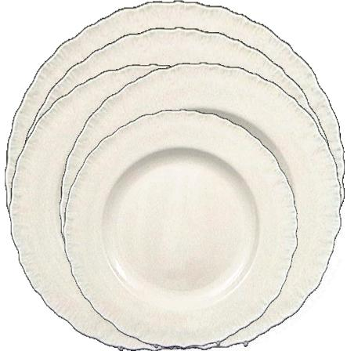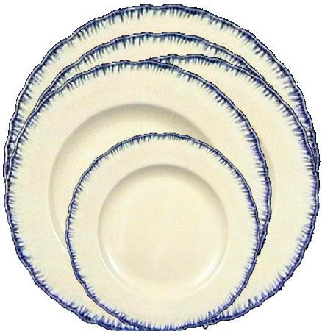

Shell Edge Creamware
Short Description | Code | Full Description  Dimensions and capacities are approximate only | Price in Pounds Sterling including VAT | Approx  Weight  In Grammes | Images  Please note because of image control difficulties the colours and sizes depicted here may not be true.  The pottery is in fact one colour and the size is indicated across
Dinner Plate | 16101 | Dinner Plate Diameter 11” (28cm) | £14.05 | 750g | 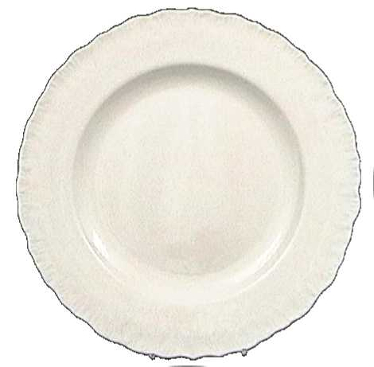
Salad Plate | 16102 | Salad Plate Diameter 9” (23cm) | £12.27 | 600g | 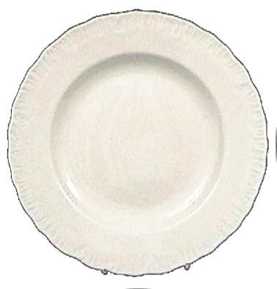
Side Plate | 16103 | Side Plate Diameter 6 1/2” (16.5cm) | £11.47 | 250g | 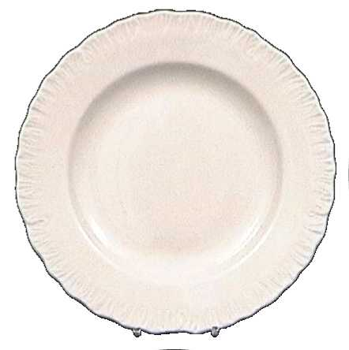
Soup Plate | 16201 | Soup Plate Diameter 9” (23cm) | £12.62 | 650g | 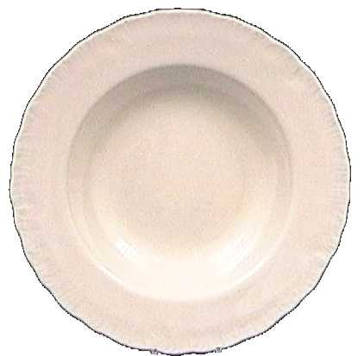
Serving Plate | 16301 | Serving Plate Diameter 12” (30.5cm) | £30.09 | 900g | 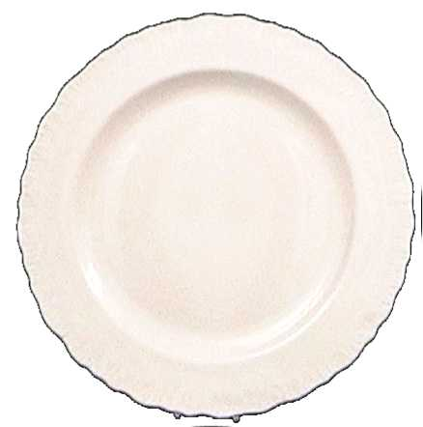
Full Set  Dinner Plate  Salad Plate  Side Plate  Soup Plate  Serving Plate | 16101-full | Dinner Plate Diameter 11” (28cm)  Salad Plate Diameter 9” (23cm)  Side Plate Diameter 6 1/2” (16.5cm)  Soup Plate Diameter 9” (23cm)  Serving Plate Diameter 12” (30.5cm) | £80.50 | 3150g
Dinner Plate | 16101B | Dinner Plate Diameter 11” (28cm)  Blue Edged | £18.45 | 750g | 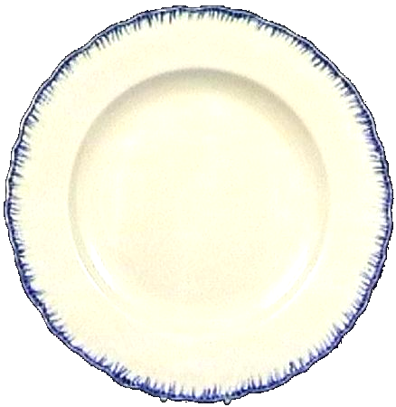
Salad Plate | 16102B | Salad Plate Diameter 9” (23cm)  Blue Edged | £16.67 | 600g | 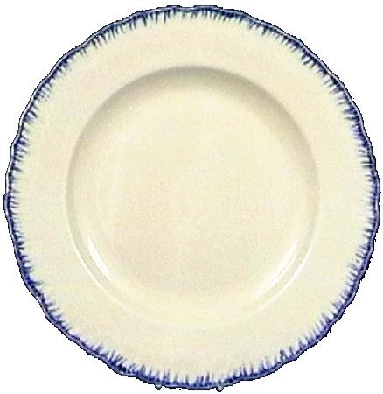
Side Plate | 16103B | Side Plate Diameter 6 1/2” (16.5cm)  Blue Edged | £15.87 | 250g
Soup Plate | 16201B | Soup Plate Diameter 9” (23cm)  Blue Edged | £17.02 | 650g | 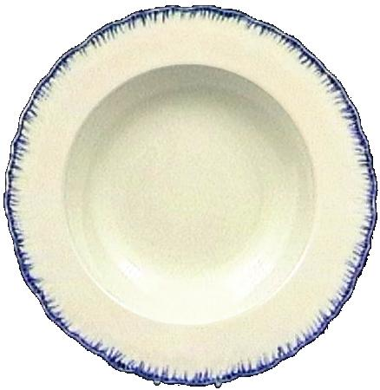
Serving Plate | 16301B | Serving Plate Diameter 12” (30.5cm)  Blue Edged | £34.49 | 900g
Full Set  Dinner Plate  Salad Plate  Side Plate  Soup Plate  Serving Plate | 16101B-full | Dinner Plate Diameter 11” (28cm)  Salad Plate Diameter 9” (23cm)  Side Plate Diameter 6 1/2” (16.5cm)  Soup Plate Diameter 9” (23cm)  Serving Plate Diameter 12” (30.5cm) | £102.50 | 3150g

Purchasing Information

Please Note all Prices include Delivery to all destinations. VAT is included for Europe and Duty for the USA. So there are no hidden additional costs, the price you see is what you pay.

There is also a discount of 10% discount available on Orders over £150 Pounds Sterling. Any Orders placed on the Web Site over this value, will automatically qualify for a 10% discount on the prices shown.

If you wish to place an order then please return to the Web Site and enter the codes from the Catalogue into the Shopping Basket page, or find each individual piece you require from the relevant room, and use the Add to Shopping Basket button.

If you would prefer an Individual Quotation, then please contact us on

Email sales@worldwideshoppingmall.co.uk

The World Wide Shopping Mall Ltd
Hillview House
Sheriff Hutton
York
YO60 6QJ
UK

Tel +44 1347 878 433
Fax +44 1347 878 539
